***ARTIFICIAL INTELLIGENCE***

***Natural Disasters Intensity Analysis&***

***Classification Using AI***

|  |  |
| --- | --- |
| ***Date*** | ***15.10.2022*** |
| ***Team Id*** | ***PNT2022TMID43723*** |
| ***Project Name*** | ***Natural Disaster Intensity Analysis &***  ***Classification Using AI*** |

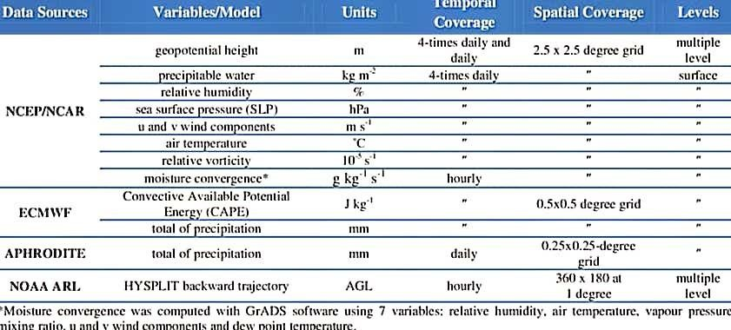 ***CYLONE***

***EARTHQUAKE***

